**SCS1301 OPERATING SYSTEM**

**UNIT I**

**Introduction-Operating system structures- System Components-OS Services-System Calls-System Structure-Resources- Processes-ThreadsObjects-Device Management-Different approaches-Buffering device drivers.**

1. **Introduction**

Operating System is a system software that acts as an intermediary between a user and Computer Hardware to enable convenient usage of the system and efficient utilization of resources.Also an operating system is a program designed to run other programs on a computer.

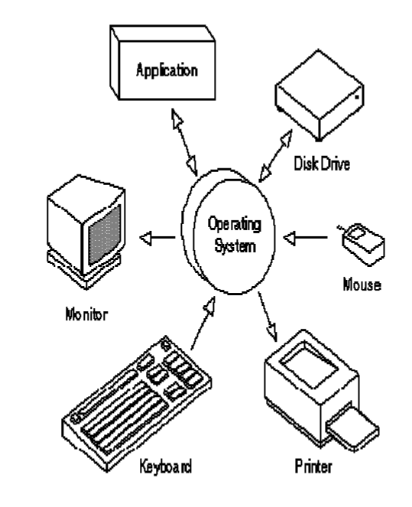

• Operating system is the most important program that runs on a computer. OS is considered as the backbone of a computer, managing both software and hardware resources. They are responsible for everything from the control and allocation of memory to recognizing input from external devices and transmitting output to computer displays.

• They also manage files on computer hard drives and control peripherals, like printers and scanners. Operating systems monitor different programs and users, making sure everything runs smoothly, without interference, despite the fact that numerous devices and programs are used simultaneously.

• An operating system also has a vital role to play in security. Its job includes preventing unauthorized users from accessing the computer system.

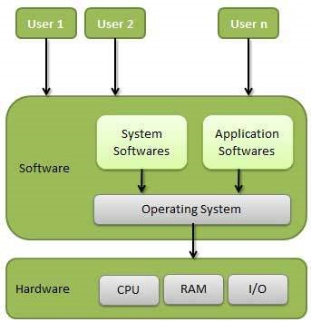

**Operating System Goals**

* Execute user programs and make solving user problems easier.
* Make the computer system convenient to use.
* Use the computer hardware in an efficient manner.

**Classification of Operating systems**

**Multi-user OS**

Allows two or more users to run programs at the same time. This type of operating system may be used for just a few people or hundreds of them. In fact, there are some operating systems that permit hundreds or even thousands of concurrent users.

**Multiprocessing OS**

Support a program to run on more than one central processing unit (CPU) at a time. This can come in

very handy in some work environments, at schools, and even for some home-computing situations.

**Multitasking OS**

Allows to run more than one program at a time.

**Multithreading OS**

Allows different parts of a single program to run concurrently (simultaneously or at the same time).

**Real time OS**

These are designed to allow computers to process and respond to input instantly. Usually, generalpurpose operating systems, such as disk operating system (DOS), are not considered real time, as they may require seconds or minutes to respond to input. Real-time operating systems are typically used when computers must react to the consistent input of information without delay. For example, realtime operating systems may be used in navigation. General-purpose operating systems, such as DOS and UNIX, are not real-time. Today’s operating systems tend to have graphical user interfaces (GUIs) that employ pointing devices for input. A mouse is an example of such a pointing device, as is a stylus. Commonly used operating systems for IBM-compatible personal computers include Microsoft Windows, Linux, and Unix variations. For Macintosh computers, Mac OS X, Linux, BSD, and some Windows variants are commonly used.

**2. Operating System Structures**

An OS provides the environment within which programs are executed. Internally, Operating Systems vary greatly in their makeup, being organized along many different lines. The design of a new OS is a major task. The goals of the system must be well defined before the design begins. The type of system desired is the basis for choices among various algorithms and strategies. An OS may be viewed from several vantage ways.

o By examining the services that it provides.

o By looking at the interface that it makes available to users and programmers.

o By disassembling the system into its components and their interconnections.

**3. System Components**

We can create a system as large and complex as an operating system by partitioning it into smaller

pieces. Each piece should be a well-delineated (represented accurately or precisely) portion of the

system with carefully defined inputs, outputs and functions. Even though, not all systems have the

same structure. However, many modern operating systems share the same goal of supporting the

following types of system components:

• Process Management

• Main Memory Management

• File Management

• I/O System Management

• Secondary Management

• Networking

• Protection System

• Command-Interpreter System

**Process Management**

The operating system manages many kinds of activities ranging from user programs to system programs like printer spooler, name servers, file server etc. Each of these activities is encapsulated in a process. A program by itself is not a process but a program in execution. For example

− A batch job is a process

− A time-shared user program is a process

− A system task (e.g. spooling output to printer) is a process.

There can be many processes running the same program. A program does nothing unless its instructions are executed by a CPU. The execution of a process must be sequential. The five major activities of an operating system in regard to process management are:

• Creation and deletion of user and system processes.

• Suspension and resumption (Block/Unblock) of processes.

• Providing mechanism for process Synchronization.

• Providing mechanism for process Communication.

• Providing mechanism for process deadlock handling.

**Main Memory Management**

Main memory is central to the operation of a modern computer system. Primary-Memory or Main Memory is a large array of words or bytes ranging in size from hundreds of thousands to billion. Each word or byte has its own address. Main-memory provides storage that can be accessed directly by the CPU. The main memory is only large storage device that the CPU is able to address and access directly for a program to be executed, that must in the main memory. To improve both the utilisation of the CPU and the speed of the computer’s response to its users, we must keep several programs in memory.

The major activities of an operating system in regard to memory-management are:

* Monitoring which part of memory are currently being used and by whom.
* Deciding which process are loaded into memory when memory space becomes available.
* Allocating and deallocating memory space as needed.

**File Management**

File management is one of the most visible components of an OS. Computers can store information on several different types of physical media (e.g. magnetic tap, magnetic disk, CD etc). Each of these media has its own properties like speed, capacity, data transfer rate and access methods. For convenient use of the computer system, the OS provides a uniform logical view of information storage.

• A file is a logical storage unit, which abstracts away the physical properties of its storage device. A

file is a collection of related information defined by its creator. Commonly, files represent programs

(both source and object forms) and data.

• The operating system is responsible for the following activities in connection with file management:

o Creation and deletion of files.

o Creation and deletion of directions.

o Support of primitives for manipulating files and directions.

o Mapping of files onto secondary storage.

o Backing up of files on stable (non volatile) storage media.

**I/O System Management**

OS hides the peculiarities of specific hardware devices from the user. I/O subsystem consists of:

o A memory management component that includes buffering, caching and spooling.

o A general device-driver interface

o Drivers for specific hardware devices.

Only the device driver knows the peculiarities of the specific device to which it is assigned.

**Secondary-Storage Management**

The main purpose of a computer system is to execute programs. These programs, with the data they

access ,must be in main memory, or primary storage.

• Systems have several levels of storage, including primary storage, secondary storage and cache

storage.

• Since main memory (primary storage) is volatile and too small to accommodate all data and programs permanently, the computer system must provide secondary storage to back up main memory.

• Most modern computer systems use disks as the principle on-line storage medium, for both programs and data.

• The operating system is responsible for the following activities in connection with disk management:

o Free-space management (paging/swapping)

o Storage allocation (what data goes where on the disk)

o Disk scheduling (Scheduling the requests for memory access).

**Networking**

A distributed systems is a collection of processors that do not share memory, peripheral devices, or a clock. Instead, each processor has its own local memory and clock, and the processors communicate with one another through various communication lines such as network or high-speed buses.

The processors in a distributed system vary in size and function. They may include small processors,

workstations, minicomputers and large, general-purpose computer systems.

The processors in the system are connected through a communication-network ,which are configured

in a number of different ways i.e.., Communication takes place using a protocol.The network may be

fully or partially connected .

• The communication-network design must consider routing and connection strategies, and the

problems of contention and security.

• A distributed system provides user access to various system resources.

• Access to a shared resource allows:

o Computation Speed-up

o Increased functionality

o Increased data availability

o Enhanced reliability

**Protection System**

• If a computer system has multiple users and allows the concurrent execution of multiple processes, then the various processes must be protected from one another's activities.

• Protection refers to mechanism for controlling the access of programs, files, memory segments,

processes(CPU) only by the users who have gained proper authorization from the OS.

• The protection mechanism must:

o Distinguish between authorized and unauthorized usage.

o Specify the controls to be imposed.

o Provide a means of enforcement.

**Command Interpreter System**

• A command interpreter is one of the important system programs for an OS. It is an interface of the

operating system with the user. The user gives commands, which are executed by Operating

system (usually by turning them into system calls).

• The main function of a command interpreter is to get and execute the next user specified command.

Many commands are given to the operating system by control statements which deal with:

o process creation and management

o I/O handling

o secondary-storage management

o main-memory management

o file-system access

o protection

o networking